Assignment 6 Xiangzhu Chen

Lo-fi and Hi-fi Prototype Write Up

**The shopping cart**

**Iteration 1**

I designed a page of the shopping cart list page last time for the InVision prototype, however it was a very rough one. There was a list of wish list items for customers to select, however, after testing this iteration with peers, I got few negative feedbacks of the wish list at bottom. Users felt that there were too many buttons which were overwhelming together with the information above. They wanted to be able to concentrate on the products they had selected. They also felt it created hassles when going back and forth between product detail page and shopping cart list page to change the quantity of a certain product.

There were also lack of important information on this iteration. Users wanted to see more details of the product they selected, for example the size and color.

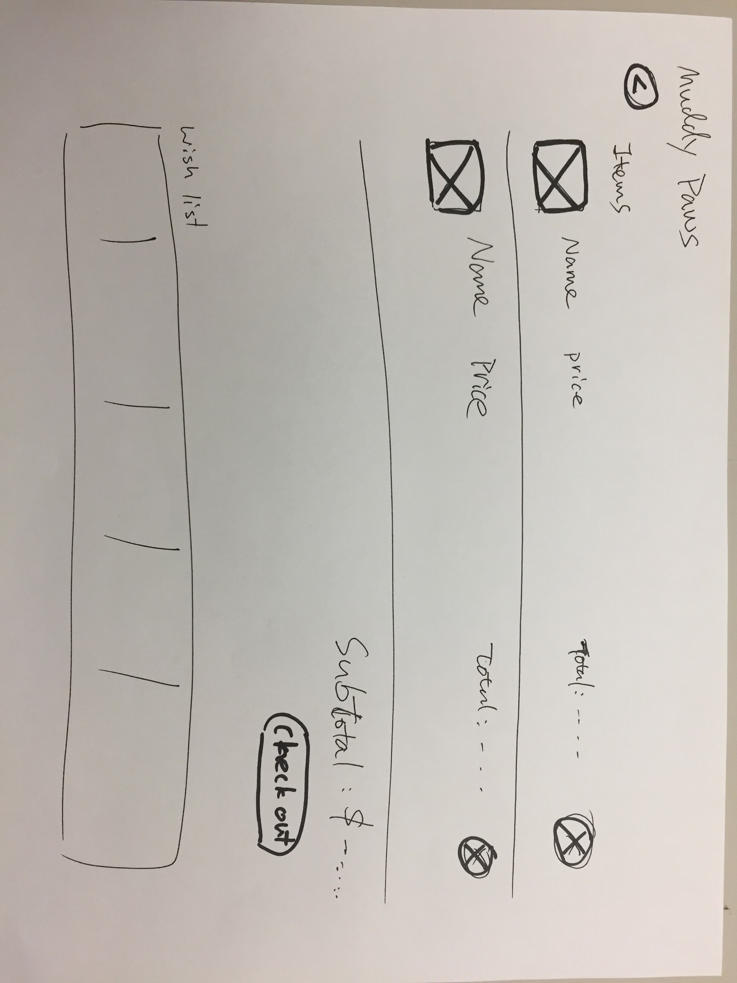

Lo-fi sketch of shopping cart list

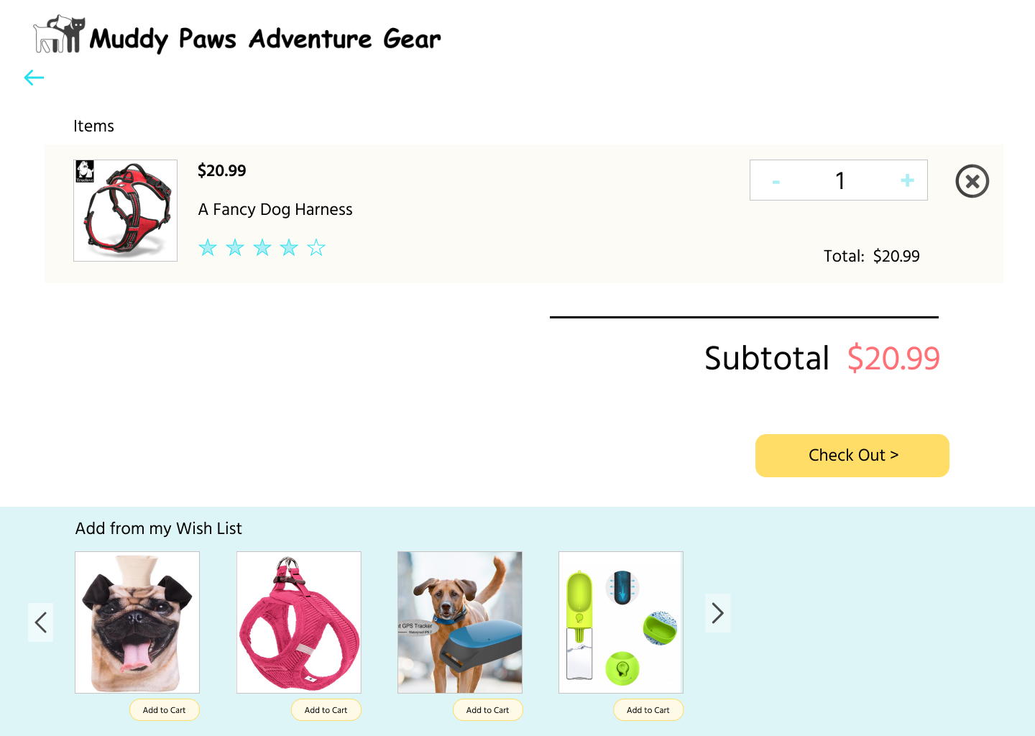

hi-fi prototype of shopping cart list (added in a quantity change box, so that users can easily change the quantity without going back)

**Iteration 2**

In this iteration, I got rid of the wish list scroll at the bottom, and made it into a separate page. The reason for this change is to reduce distractions and help users focus on checking out their selected products.

In addition to that, I added size, color, shipping price (in this case free) under each row of selected products to give more information to users for them do better review their choices and make a checkout decision.

After adding in the wish list, I also added an entry to it on the shopping cart page, so that users can add in their favorite items when needed.

Above design decisions were made largely due to the purpose of providing users a clean, easy, and flexible way of reviewing/adding/deleting selected products.

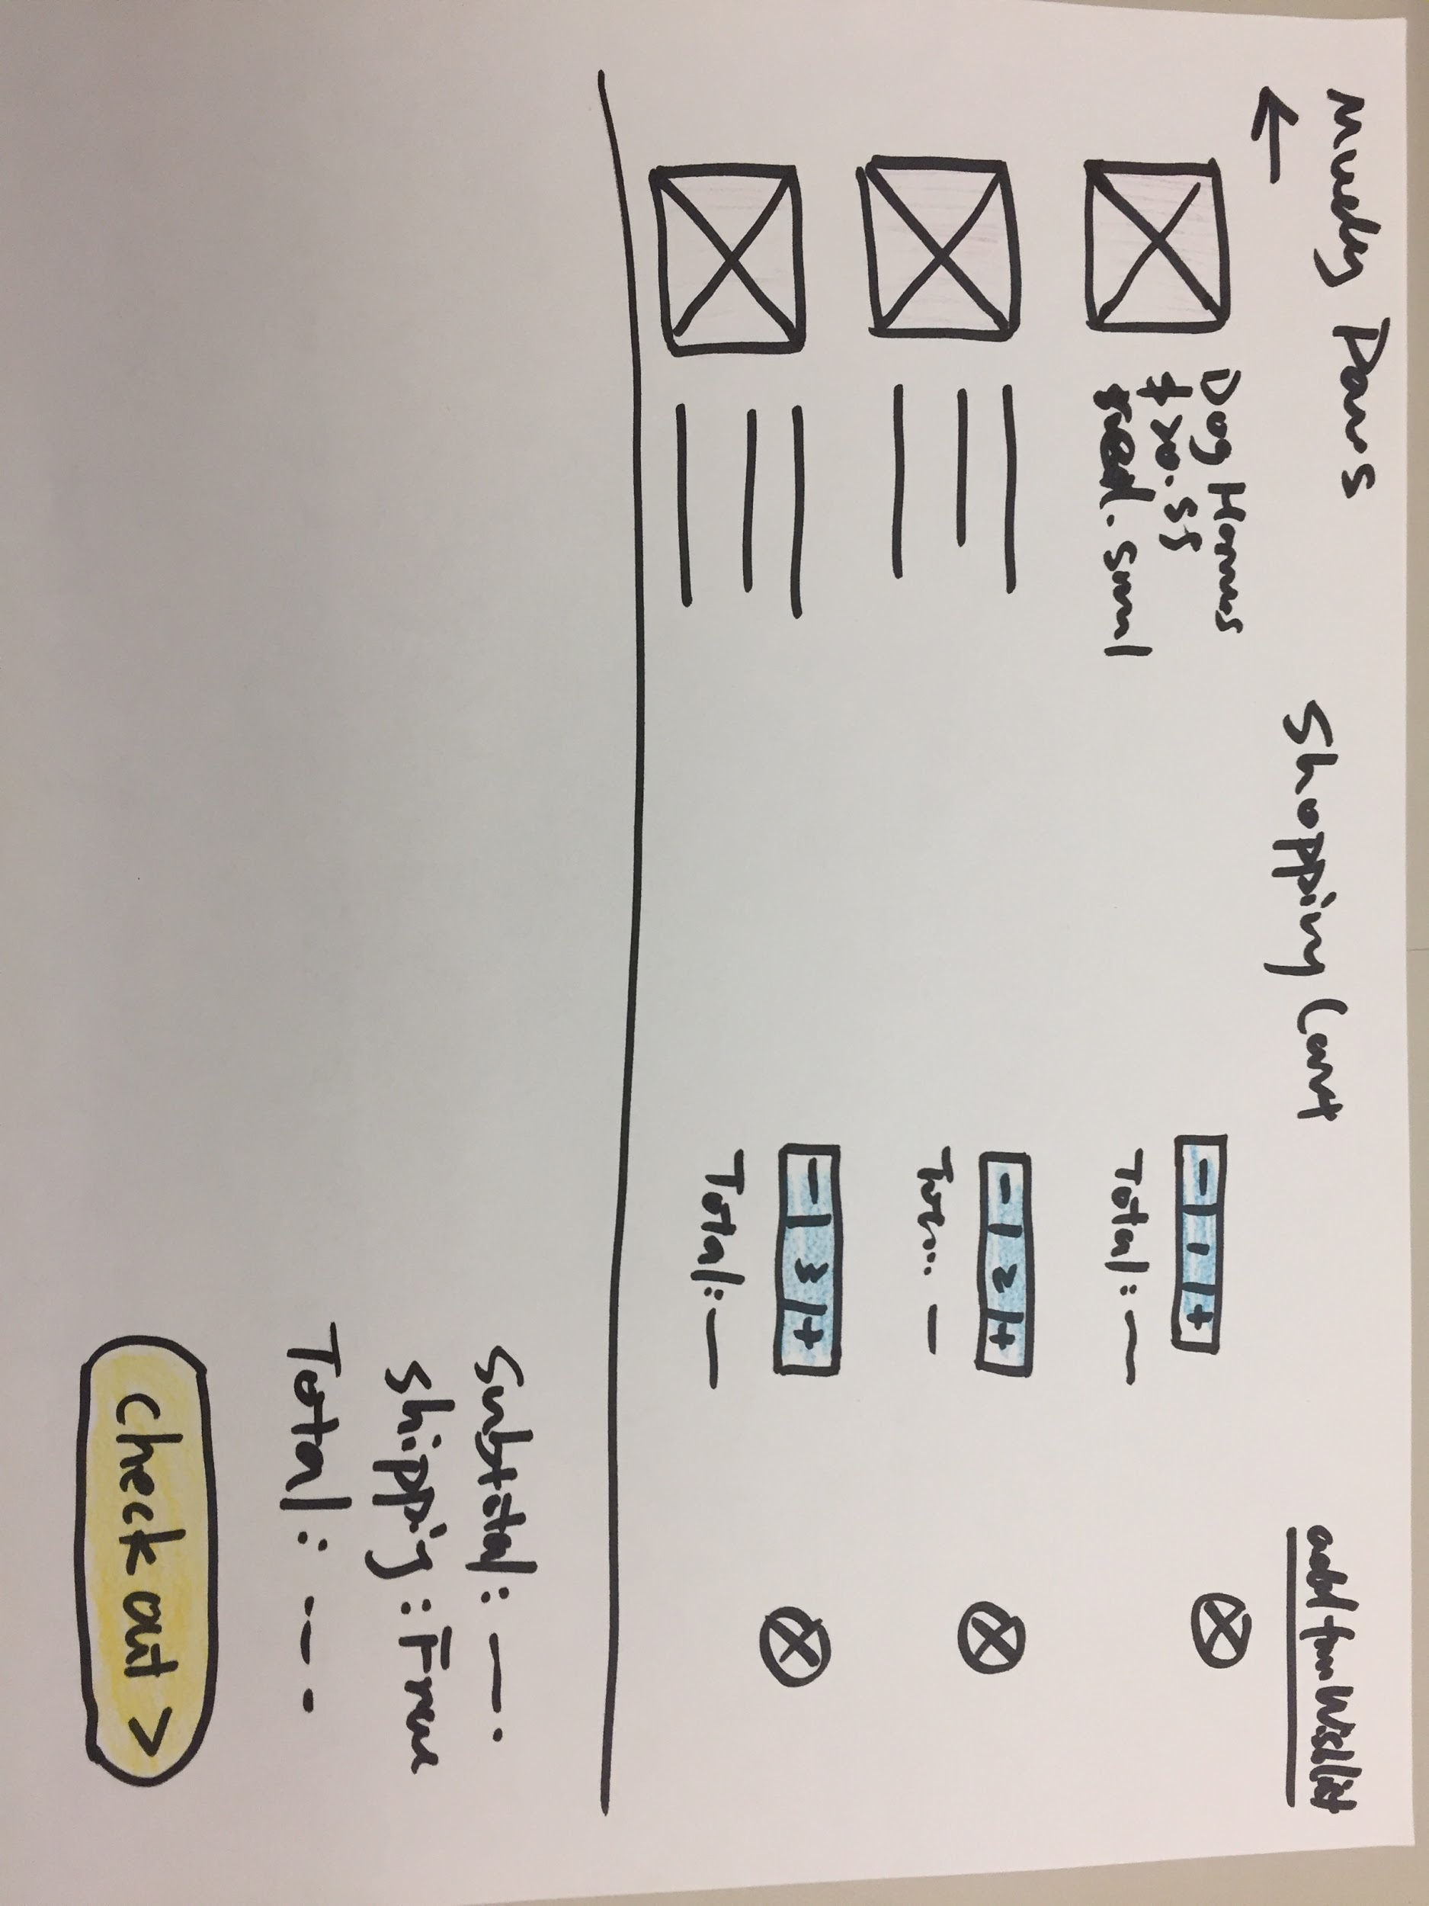

Shopping cart page lo-fi prototype

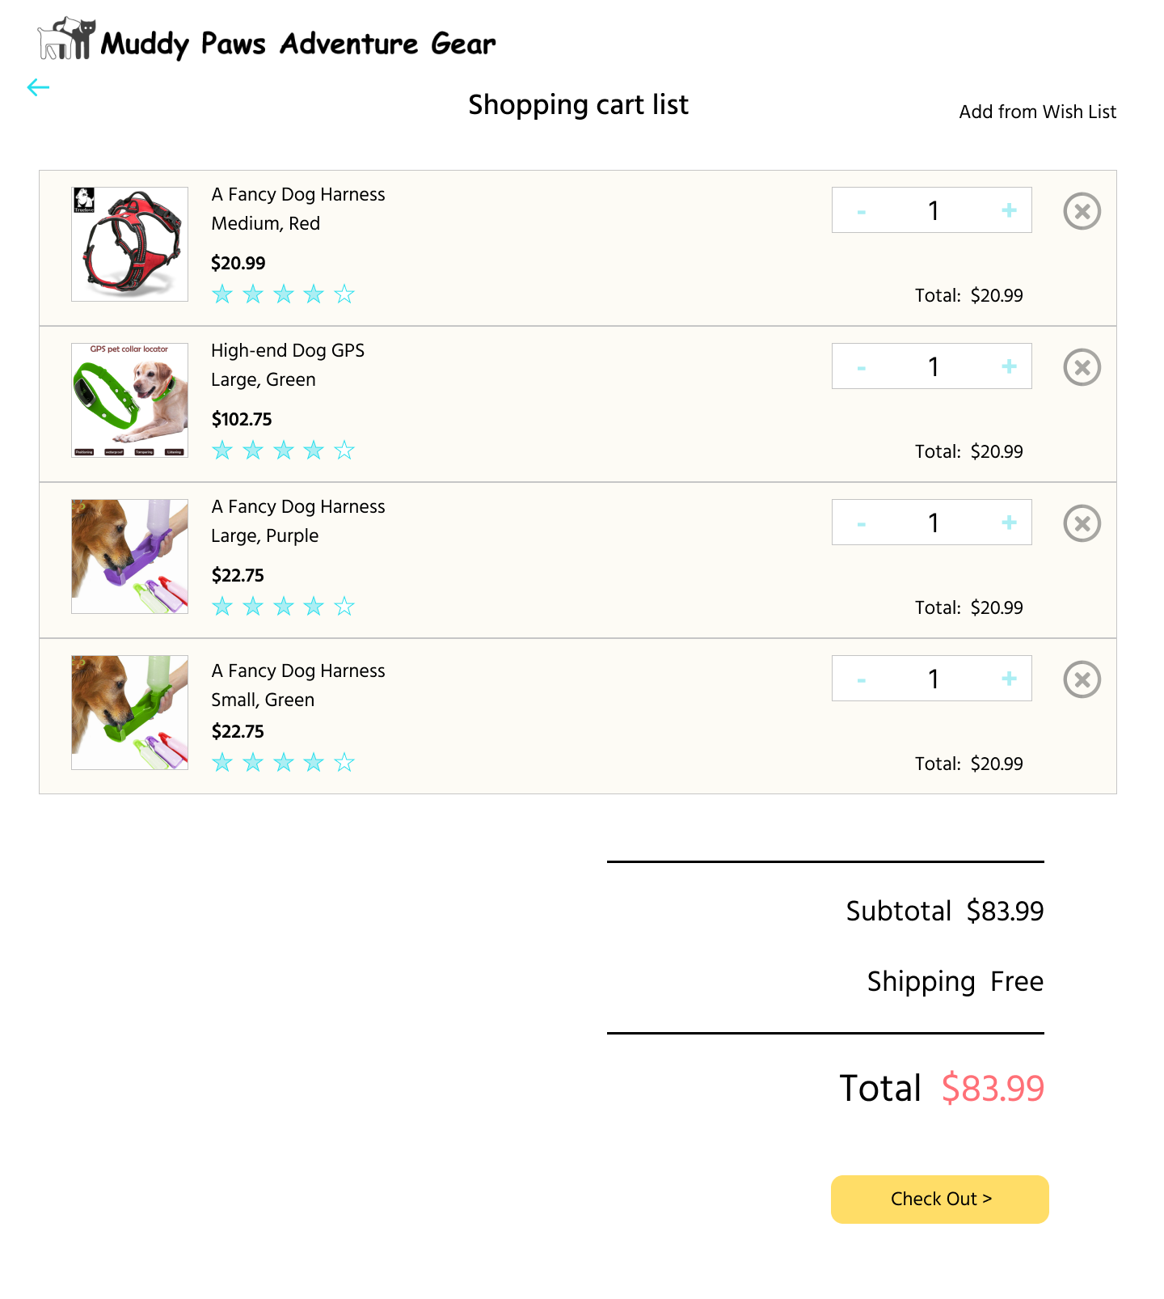

Shopping cart hi-fi prototype

**The product detail page**

In this iteration, the major changes were 1) adding “add to wish list” button and wish list FAB(floating action button, the button that floats on the page and provides additional actions) for the wish list feature, and 2) a carousel of related items to provide customers more choices.

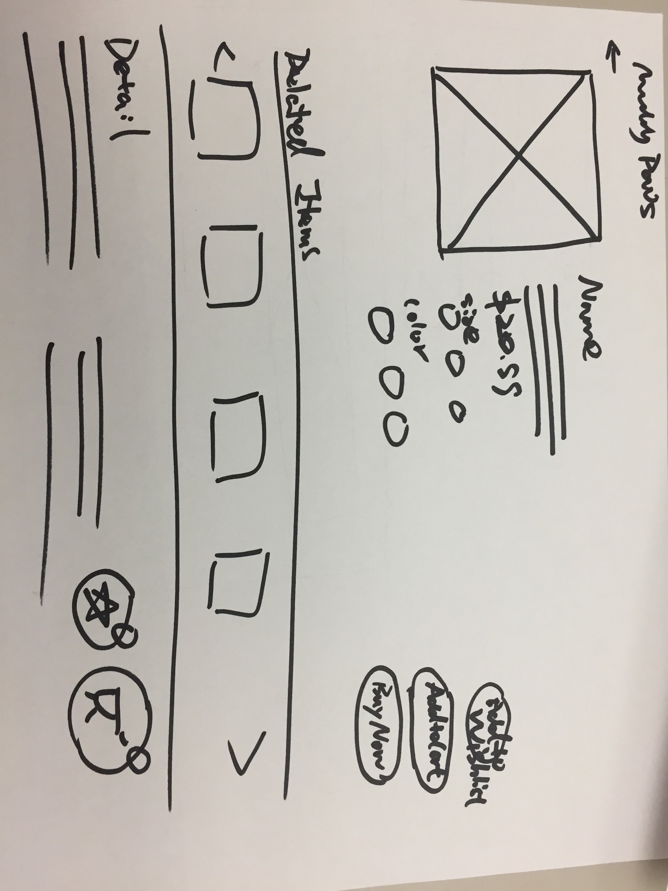

Revised product detail page lo-fi prototype

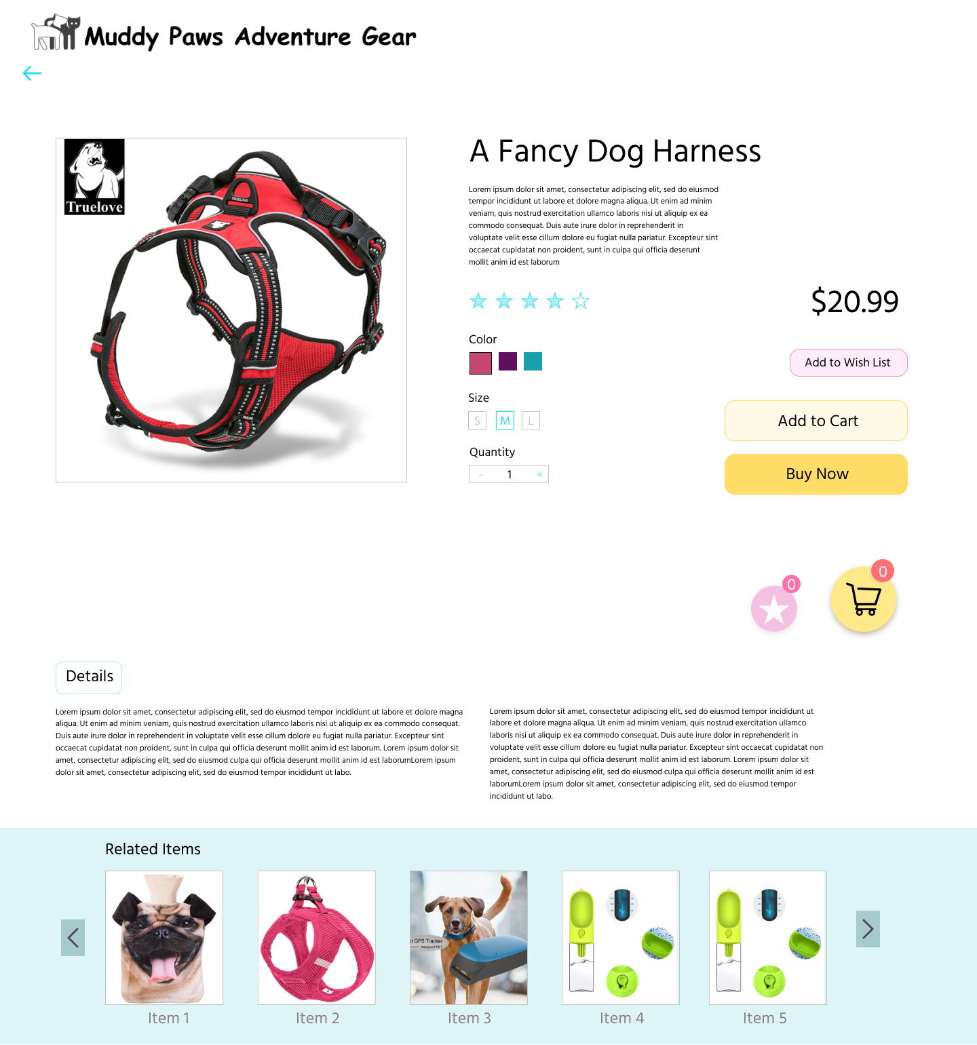

Revised product detail page hi-fi prototype (I changed the sequence of the carousel and the detail section, because the detail section and the product information should be one group of information, which needs to be visually grouped together as well)

**The Wish List**

The wish list is similar to the shopping cart list, however, there’s no quantity nor total prices based on that. Instead, I added “add to cart” button for each of the product, so that customers can easily add their favorites to the cart.

Beneath the list of products, there are buttons of wish list and shopping cart for customers to track the quantity in each of them and get access to shopping cart page conveniently.

When showing the prototypes to peers, the design of two FABs were welcomed due to their bright colors that match the overall color theme, and

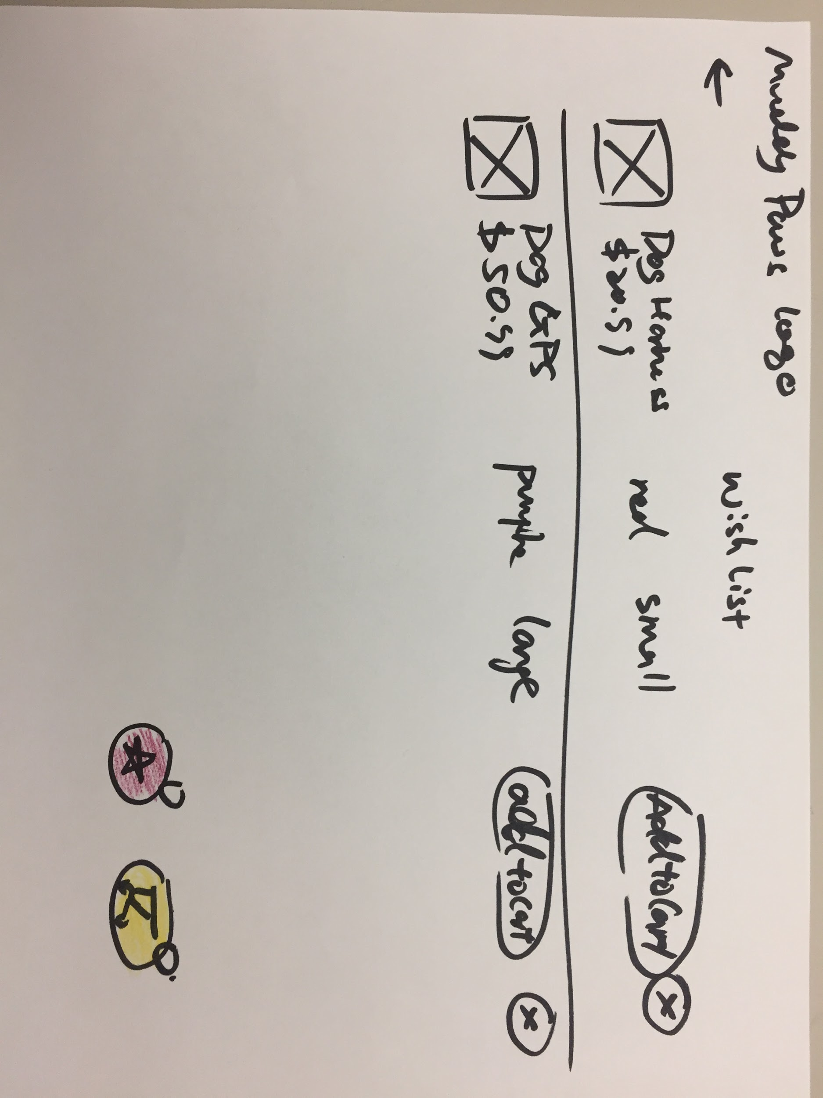

The wish list lo-fi prototype

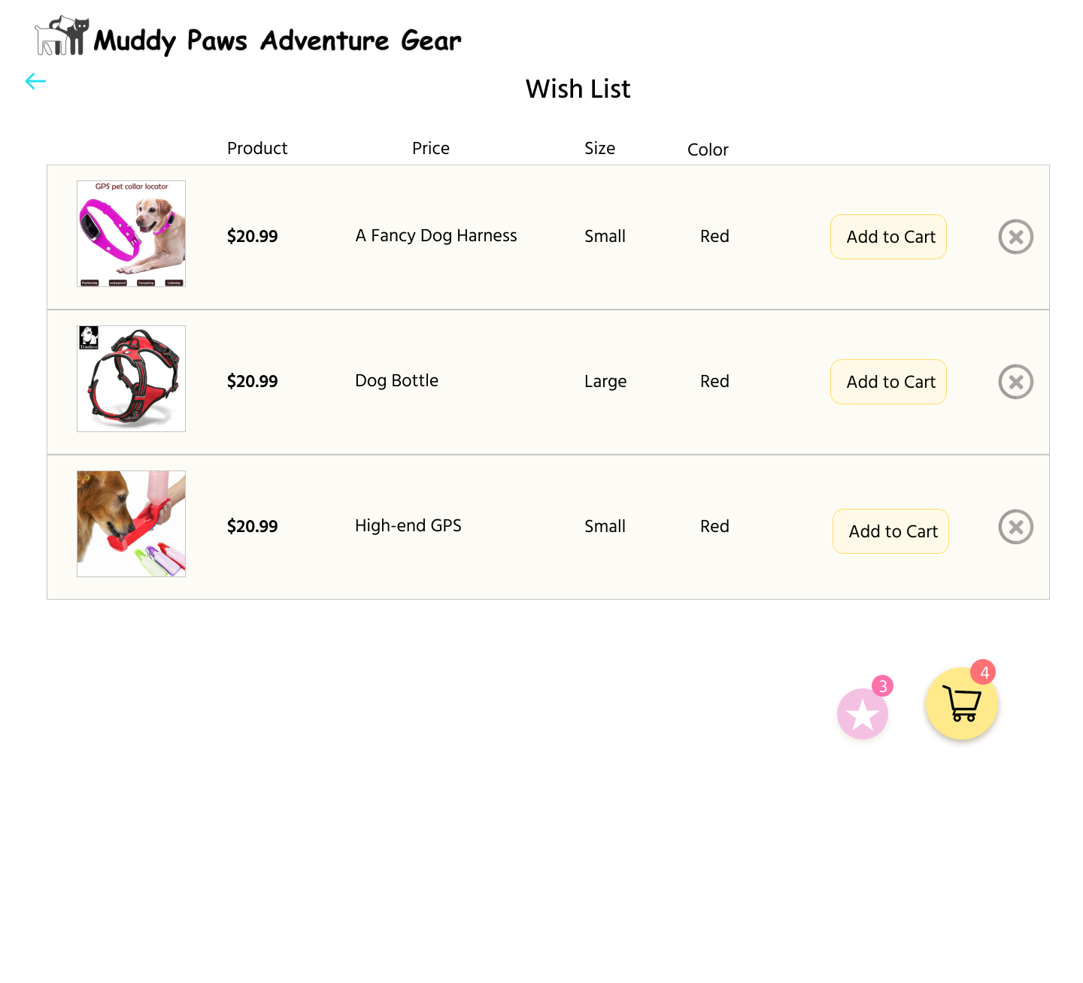

The wish list hi-fi prototype